1天背完中考动词过去式、过去分词（不规则变化）
动词的不规则变化很多同学头痛，今天放在一文里，方便同学复习。（摘自外研社版9年级下）复习之前，也回顾一下规则的变形规则，看看还记得多少？
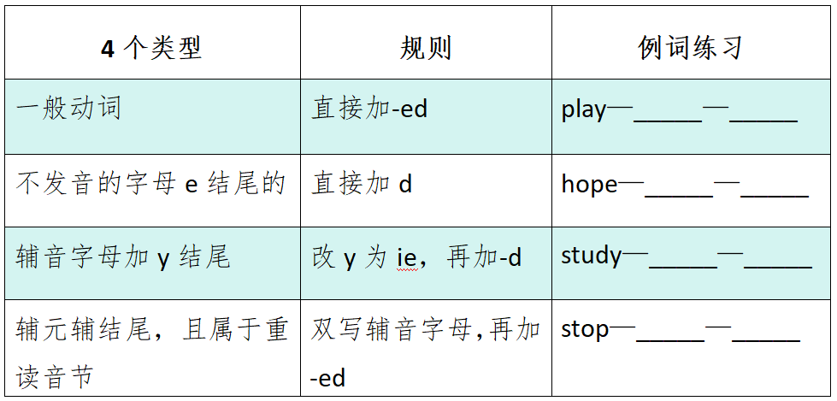那不规则的是不是真的就无迹可寻了呢，其实也不是。下面的希望能帮到同学。1.动词过去式与动词原形一样：let-let-let, put-put-put, cut-cut-cut2. i-a-u：sing-sang-sung, begn-began-begun,swim-swam-swum3.过去式以ought/aught结尾的单词：bring-brought-brought, buy-bought-bought, think-thought-thought4.中间ee-e_ t：feel-felt-felt, keep-kept-kept, sleep-slept-slept5. i-o-d_en：ride-rode-riden, drive-drove-driven,6.ow/aw-ew-own: know-knew-known, grow-grew-grown, throw-threw-thrown7. d-t：build-built-built, lend-lent-lent, send-sent-sent